COS125 Assg #9 Name: Nicholas Soucy
Due: Friday 11/17/17
Late: Friday 11/24/17

Part I. (20 pts.)

1. (2) According to object-oriented design principles, objects should be self-governing, meaning instance variables of an object should be modified only by that object. This concept is known as ___________.

b. encapsulation

2. (2) Generally, variables declared within a class use ____________ visibility and methods use ____________ visibility.

b. private, public

3. (2) Which is the best definition of overloaded methods?

b. Multiple methods with the same name but different parameter lists.

4. (2) Accessor methods in a class are often marked with a name beginning with _______.

a. get

5. (2) Constructor methods in a class are marked with a name of _______.

c. the class name

6. (2) Class methods marked with public scope may be called by _______________.

c. both class and main methods

7. (2) Class variables marked with private scope may be accessed by _______________.

a. only class methods

Use the Temperature class to answer questions.

public class Temperature {
private double temp; // temperature stored in Celsius units
public Temperature ( ) // POST: temperature initialized to 0 degrees C
{ temp = 0.0; }
public Temperature (double t ) // POST: temperature initialized to t degrees C
{ temp = t; }
public void setTemp (double t) // POST: temperature set to t degrees C
{ temp = t; }
public double getTemp ( ) // POST: return the Celsius temperature
{ return temp; }
public double convert ( ) // POST: return the Fahrenheit equivalent
{ return 9.0/5.0 * temp + 32.0; }
public boolean equals(Temperature t) // POST: return true if same temperatures
{ return temp == t.getTemp( ); }
}

8. (2) The main method of a client class attempts the following code to set object winter temperature but an error results. What is the cause of the problem?

Temperature winter;
winter.setTemp (23);

a. The setTemp method expects to be passed a double value..

9. (2) Write code to display “SAME” if the two objects t1 and t2 store the same temperature value using a class method.

Temperature t1 = new Temperature (15.0);
Temperature t2 = new Temperature (32.5);

public String compare (t1, t2)
{ if (t1 = t2)
SOP(“SAME”);
else
SOP(“DIFFERENT”); }
_______________________________________________________________

10. (2) What statement is true about class variable temp of object day?

Temperature day = new Temperature ( );

a. The temp member of object day stores value 0.0.

Part II: (80 pts) ) Write a program to solve the following problem. Name the Box class Box.java and the main application A9YourName.java (use your own name). These two classes should be stored in one package. Upload both files to Blackboard Assignment #9 link as well as document of answers. (Note: Failure to upload both java files and all output screen shots minimally incurs the late penalty.)

Design a Box class (Box.java) with data members for integer length, width, and height, accessor and modifier methods and methods for area and volume. Include a default constructor setting dimensions to 1 and a parameterized constructor where the user passes in desired dimensions. Include PRE and POST comments. Test the Box class before writing the application.

Write an application (A9YourName.java) which uses Box objects. The company sells snow globes which come in a variety of cubic container boxes measured in inches. Some quantities of a snow globe (one size only) need to be shipped from one store to another. The company would like to know how many shipping boxes of various types are required and the cost for each. Packing material costs $0.0023 per cubic inch. Packing material is only needed on partially filled shipping boxes. Plastic wrap around the sealed box costs $0.0012 per square inch.

Input: The user will enter the dimensions of the shipping box. Valid dimensions are multiples of 4 inches (Ex. 4 x 8 x 12 box is acceptable while 3 x 7 x 16 box is not valid). The user enters the box cost. The user enters the snow globe dimension. Valid dimensions are multiples of 4 such that at least one globe fits in the box. (Ex. If the shipping box is 4 x 8* 8 inches, then the snow globe cannot be 8 inches or more as not even one fits.) Use error detection loops to ensure valid data (see Test Case 1). The main loop allows the user to input any number of orders, using value 0 as the sentinel (see Test Case 2).

Output: You will run 3 test cases to turn in. See attached samples for report content.

Test Case 1: Error checking
Test Case 2: Valid data
Test Case 3: Ship box: 24 x 16 x 8
Box cost: $4.99
Snow globe: 8
Quantities: 1 5 6 50

Notes:
- Code must make use of two Box objects, one for the shipping box and one for the snow globe container. Once the Box object is declared, only Box methods may be used.
- Use a NumberFormat object to display the costs in Currency.

Test Case 1:

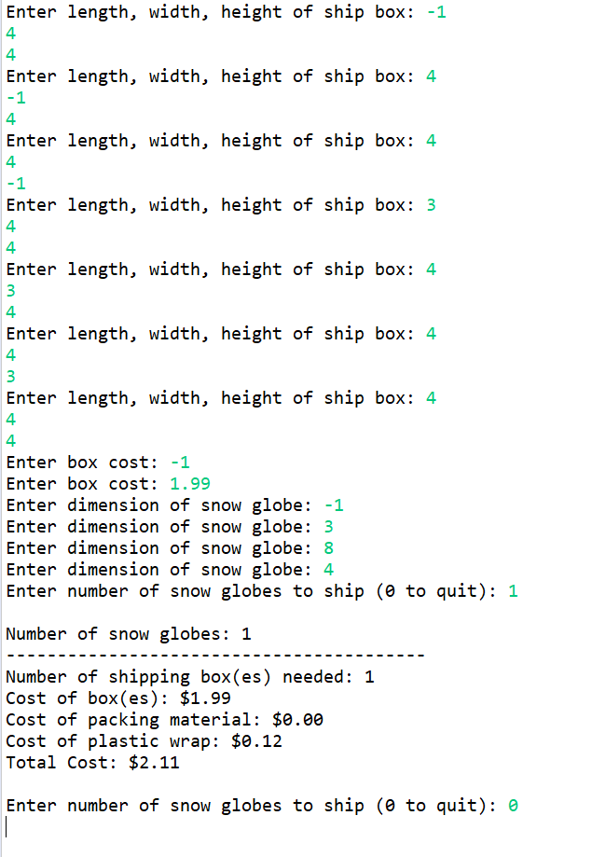
Test case 2:

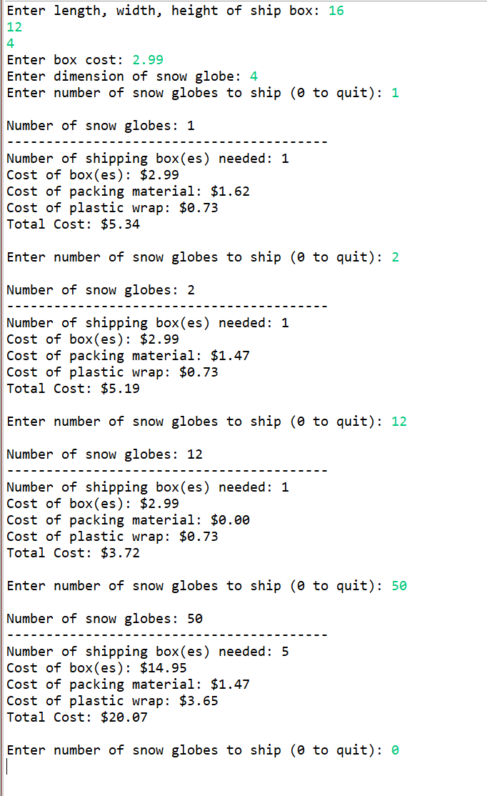

Test 3
